Ex No 11:
Tor
Aim:
To understand the working of the Tor network and how it enables anonymous communication over the internet.
To learn how to access and navigate websites on the Tor network using tools like Tor Browser and Proxychains

Procedure:
- Log in to the TryHackMe platform and open the Tor for Beginners room.
- Study the basics of the Tor network, including how it routes traffic through multiple relays for anonymity.
- Set up or use the Tor environment (e.g., Tor Browser or Tails OS) to connect to the Tor network.
- Access .onion websites provided in the tasks and observe how anonymous browsing works.
- Analyze the results and retrieve required information (flags) from Tor-hosted pages to complete the tasks.

Task 1: Unit 1- Tor
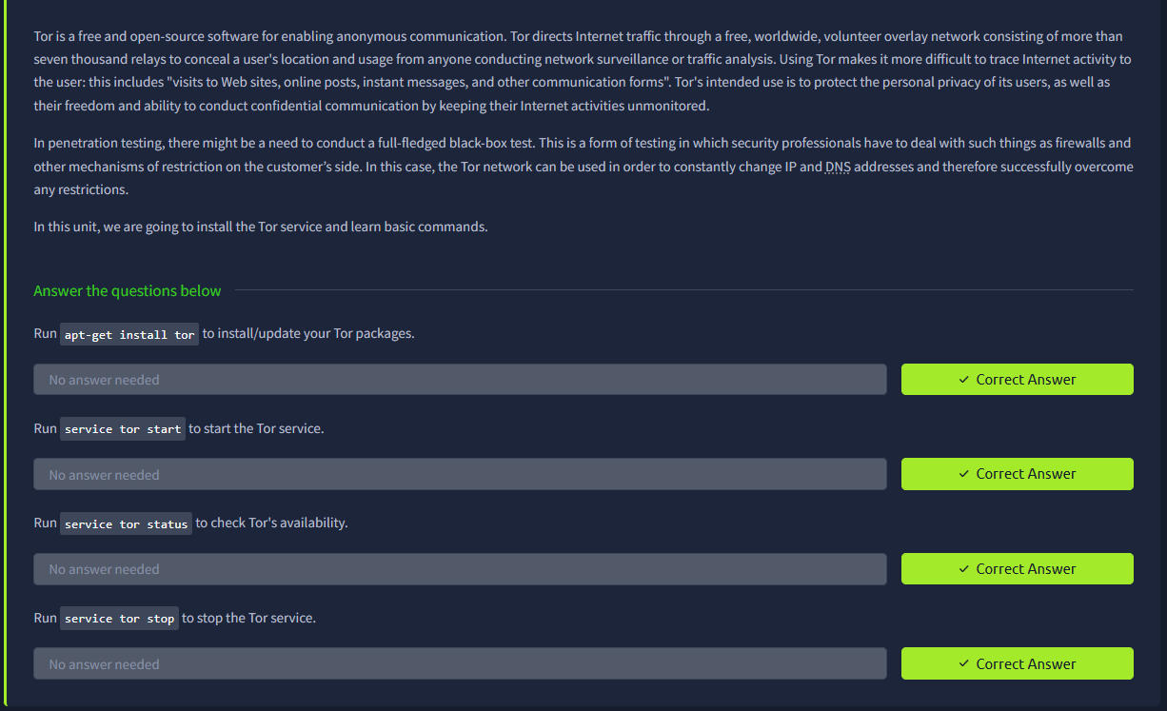
Task 2: Unit 2- Proxychains
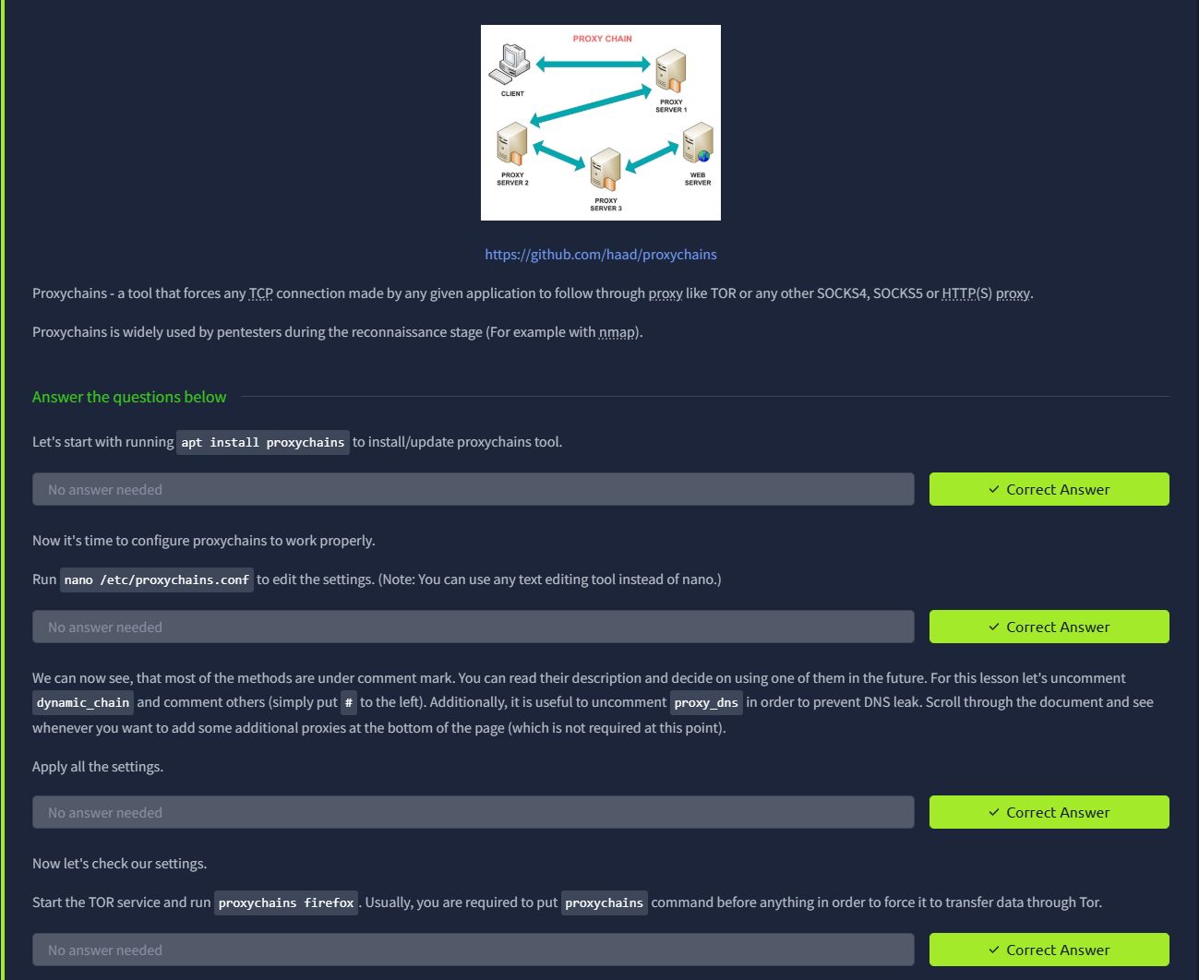
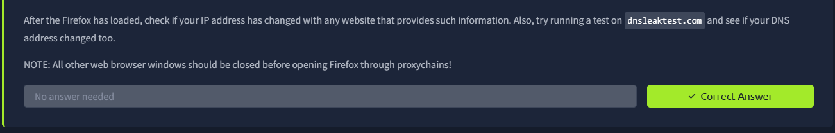
Task 3: Unit 3- Tor Browser
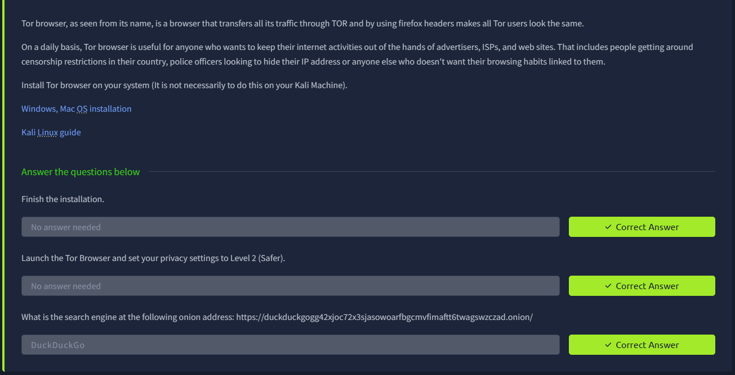
Result:
Successfully understood the fundamentals of the Tor network and its role in maintaining user anonymity online.
Gained practical experience in accessing hidden services and browsing securely through the Tor network.

